19.64: a)

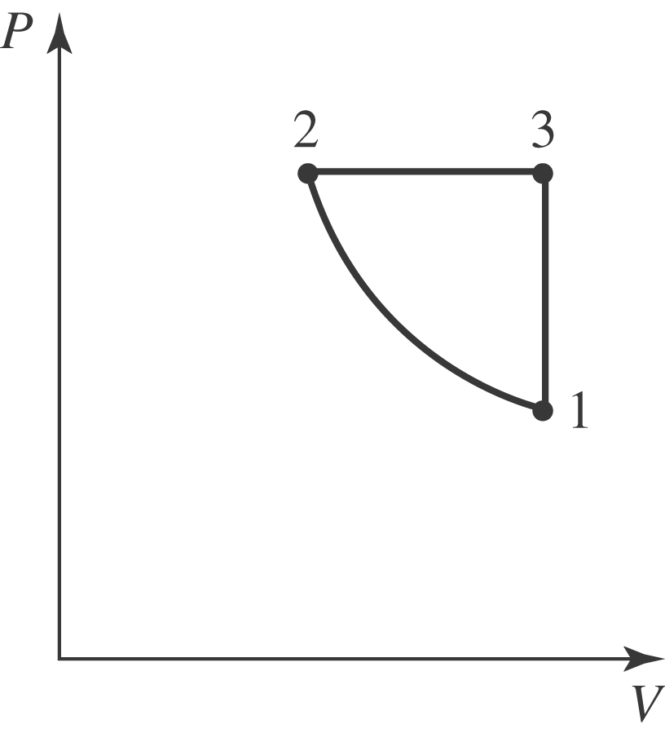

b) At constant pressure, halving the volume halves the Kelvin temperature, and the temperature at the beginning of the adiabatic expansion is 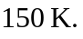The volume doubles during the adiabatic expansion, and from Eq. (19.22), the temperature at the end of the expansion is 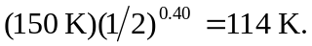 c) The minimum pressure occurs at the end of the adiabatic expansion. During the heating the volume is held constant, so the minimum pressure is proportional to the Kelvin temperature,

